|  |
| --- |
| iUTOPIA |
| system design specifications document |
|  |
| This document serves to provide details on the system design specifications for the iutopia web application. The document dives into the details of the functional and non-functional specifications of the web application, aided by UML diagrams and visualizations. |
|  |
| *By: Tinashe Jamanda* |
| 10/31/2021 |
|  |

**System Design Specifications**

Table of Contents

**Document Overview**

This document serves to provide a detailed outline of the functional and non functional design specifications for iUtopia web based application. I have also attached diagrams and visualizations in Unified Modeling Language to portray the system’s design structure in detail. iUtopia is a web application built on PHP, JavaScript, Angular JS, Ajax, J Query, CSS, HTML and MySQL.

**Methodology Used**

I adopted a rather, one-man agile approach, sourcing ideas from self studying and research. This project has used principles taught by Robin Nixon in one of his O’Reilly books.

**Architectural Design**

**Application Architecture**

Application Architecture is a client server architecture of an application, consisting of 3 layers i.e., interface, business logic process, and data. These functionalities are developed and maintained independently.

Presentation Layer: This is the top level known as the user-interface, which displays and accepts input from users. (HTML, CSS, J-Query)

Business Logic Layer: Business logic is a program that handles data validation and manages communication between an end user and the database. (JavaScript, Ajax, Angular JS, PHP)

Database Layer: The database is a place where information is stored and retrieved through the business logic layer. (phpmyAdmin, MySQL)

Benefits of 3-Tier Architecture: scaling all tiers is easier, e.g. backend layer allows you to deploy to a variety of databases instead of being fixed on a particular technology.

**Software Requirements**

Software requirements are the tools and descriptions used for system development and use post implementation and deployment.

|  |  |
| --- | --- |
| Device Types | Desktop  Laptop  Smart Tablet  Smart Phone |
| Operating System | Windows 7 or Higher  OS  Android  Blackberry |
| Processor | Intel Pentium 4.1.5 or Higher |
| Memory | 256MB RAM |
| Hard Drive | 200MB Free HDD space |
| Media | 8x Speed CD-ROM |
| Graphics Hardware | Nvidia GForce 5xxx Series or Similar |
| Network | Broadband Recommended |
| IDE | Atom  SQL Server 2018 Workbench |
| Development Server | XAMPP 7.3.31  (Apache + MariaDB + PHP+ Perl) |
| Deployment Server | Cloud Firebase |
| Web Browser | Chrome Current Version  Firefox Current Version  Safari Current Version  Microsoft Internet Explorer Current Version |
| Web Browser Settings | Cookies Enabled  JavaScript Enables |
| Peripherals | Monitor  Keyboard  Mouse |

**Function and Program Design**

**Design Level Use Cases**

A use case diagram functions to explicitly show how the system interacts with the actors which may be human or other systems within its domain. The actor’s interactions with the system are referred to as use cases.

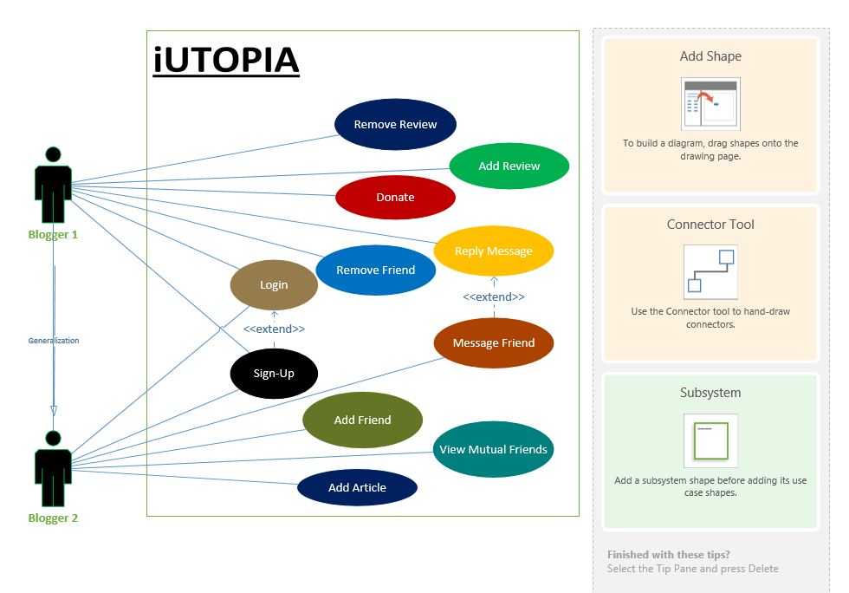

iUtopia is a decentralized platform where all user groups have the same rights and privileges to the systems functionality . System administration is only available to keep the technology up to date after new releases. **\*\*\****Technologies to stay up to date with shall be PHP, MySQL, Firebase Platform, JavaScript version updates.* **\*\*\***

**Use Case Narrative Specifications**

The use case narrative serves to provide more in-depth details about the processes and elements involved in each use case. The use case narrative includes (but is not limited to):

Use Case Name: *Uniquely identifies the use case.*

Brief Description: *Provides a description of the use case in simple informal language.*

Actor(s): *Gives a list of actors (maybe Human or another external system).*

Pre and Post Conditions: *Preconditions are true before/at beginning of the process; Post conditions are true if the process is successful.*

Main Flow: *Describes the sequence of actor to system interactions and the resultant behavior.*

Alternative Flow: *This outlines what happens if the process is not successful.*

Author of the Narrative: *This is simply the name is whoever the creator of the narrative is.*

|  |  |
| --- | --- |
| Use Case #1 | Sign Up |
| Brief Description | User registration to be able to actively participate on the platform. |
| Actor(s) | Unregistered Users. |
| Pre Condition | User has not been registered onto the platform before. No existing username. |
| Post Condition | User is granted privileges to login the system and participate with unique username. |
| Main Flow | Fill in the signup form fields with unique username. Verify contact email address. |
| Extend | Upon success the user may proceed to log into the system. |
| Author of Narrative | Tinashe Jamanda |

|  |  |
| --- | --- |
| Use Case #2 | Login |
| Brief Description | Add credentials on login form to access user profile. |
| Actor(s) | Registered User. |
| Pre Condition | User is already registered onto the platform. |
| Post Condition | User is granted access to the user profile with active privileges. |
| Main Flow | User enters valid credentials onto the user form. Upon success the user has access to the profile to update profile, send messages, and add articles and reviews. |
| Alternative Flow | If a session already exists, user is welcomed back, and automatically logged in. |
| Author of Narrative | Tinashe Jamanda |

|  |  |
| --- | --- |
| Use Case #3 | Add Article |
| Brief Description | Post an article to be published onto the profile |
| Actor(s) | Registered User |
| Pre Condition | User should be registered an d logged onto the user profile to post an article. |
| Post Condition | The article is sent to the admin for review before publishing. |
| Main Flow | User loges onto their profile on the platform, before posting an article for admin to review prior to publishing. |
| Alternative Flow | Should the user be logged in already, they simply publish the profile. |
| Author of Narrative | Tinashe Jamanda |

|  |  |
| --- | --- |
| Use Case #4 | Add Friend |
| Brief Description | Add a friend to user’s profile friend list. |
| Actor(s) | Registered Users. |
| Pre Condition | User must be registered and logged into profile. The friend must be listed as a member of the iutopia social platform. |
| Post Condition | The user is now able to send private messages to the added friend. The friend is now listed on the user’s profile as a friend. |
| Main Flow | User logs onto user profile, views the members list and adds friends by following them. |
| Alternative Flow |  |
| Author of Narrative | Tinashe Jamanda. |

|  |  |
| --- | --- |
| Use Case #5 | Remove Friend |
| Brief Description | Remove friend from friend list and stop following their profile. |
| Actor(s) | Registered User |
| Pre Condition | The friend already existing on the friend list of the logged in user. |
| Post Condition | The friend is no longer listed on the registered user’s profile. |
| Main Flow | Registered user logs onto their profile and un follows friend to remove the friend from the friend lists. |
| Alternative Flow |  |
| Author of Narrative | Tinashe Jamanda |

|  |  |
| --- | --- |
| Use Case #6 | Message Friend |
| Brief Description |  |
| Actor(s) |  |
| Pre Condition |  |
| Post Condition |  |
| Main Flow |  |
| Alternative Flow |  |
| Author of Narrative |  |

|  |  |
| --- | --- |
| Use Case #7 | Donate |
| Brief Description |  |
| Actor(s) |  |
| Pre Condition |  |
| Post Condition |  |
| Main Flow |  |
| Alternative Flow |  |
| Author of Narrative |  |

|  |  |
| --- | --- |
| Use Case #8 | Add Review |
| Brief Description |  |
| Actor(s) |  |
| Pre Condition |  |
| Post Condition |  |
| Main Flow |  |
| Alternative Flow |  |
| Author of Narrative |  |

|  |  |
| --- | --- |
| Use Case #9 | Remove Review |
| Brief Description |  |
| Actor(s) |  |
| Pre Condition |  |
| Post Condition |  |
| Main Flow |  |
| Alternative Flow |  |
| Author of Narrative |  |

**Program Design**

**Detailed Sequence Diagrams**

**Design Class Diagram**

**Package Diagram**

**User Interface Design**

**General Considerations**

**Ten Usability Heuristics**

**Forms and Forms Specifications**

**Reports and Reports Specifications**

**User Interface Dialogues**

**Help Design**

**Database Design**

**Target Database Selection**

**Relational Database Model Diagram**

**Relationship Model**

**Attribute Property Specification**

**Backup and Recovery Facilities**

**Project Matters**

**Open Issues**

**Assumptions and Change Control**

**Updated Schedule and Budget**

**Appendices**

**Glossary**

**Business Documents and Forms**

**References**

**Attachments**

**Design Class Diagram**

**Relational Database Model Diagram**

**Attribute Property Specification**